**DECIMAL TO BINARY CONVERSION**  
**EXP NO: 25**

**AIM:**To write a C program to implement decimal to binary conversion.

**ALGORITHM:**  
1) Check if your number is odd or even.  
2)  If it's even, write 0 (proceeding backwards, adding binary digits to the left of the result).   
3)   Otherwise, if it's odd, write 1 (in the same way).  
4)   Divide your number by 2 (dropping any fraction) and go back to step 1. Repeat until your original number is 0. 

**PROGRAM:**

#include<stdlib.h>

int main()

{

int a[10],n,i;

printf("Enter the number to convert: ");

scanf("%d",&n);

for(i=0;n>0;i++)

{

a[i]=n%2;

n=n/2;

}

printf("\nBinary of Given Number is=");

for(i=i-1;i>=0;i--)

{

printf("%d",a[i]);

}

return 0;

}

   
  
  
   
  
  
   
  
  
  
  
  
**INPUT:**  
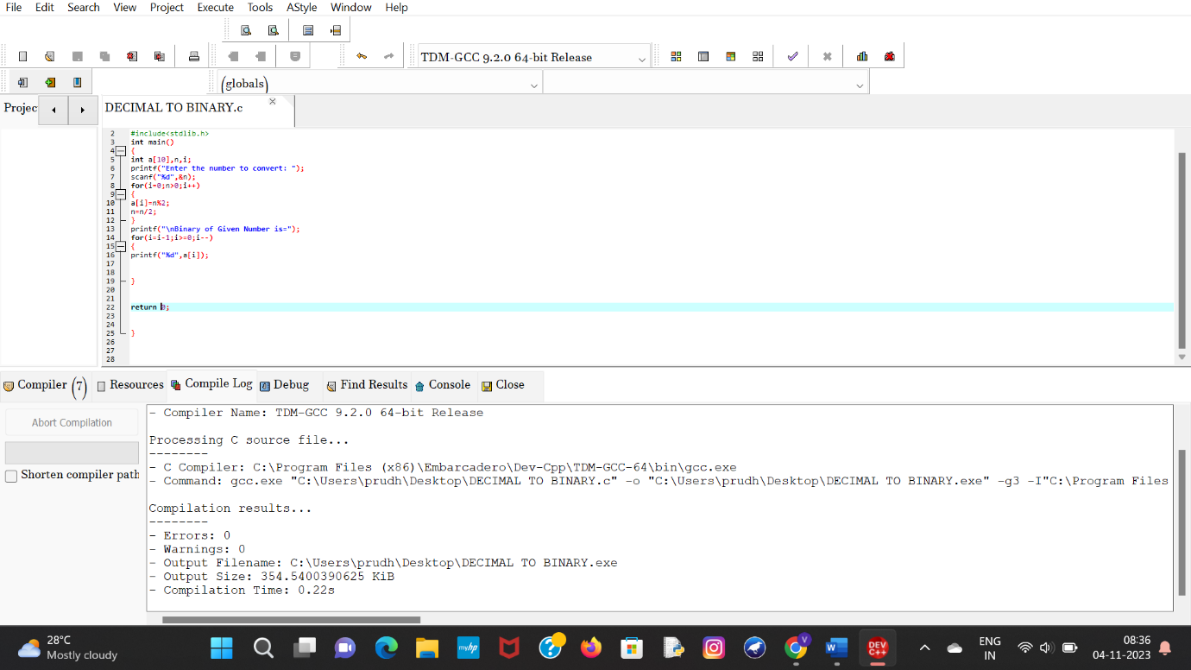  
  
  
  
  
  
**OUTPUT:**  
  
  
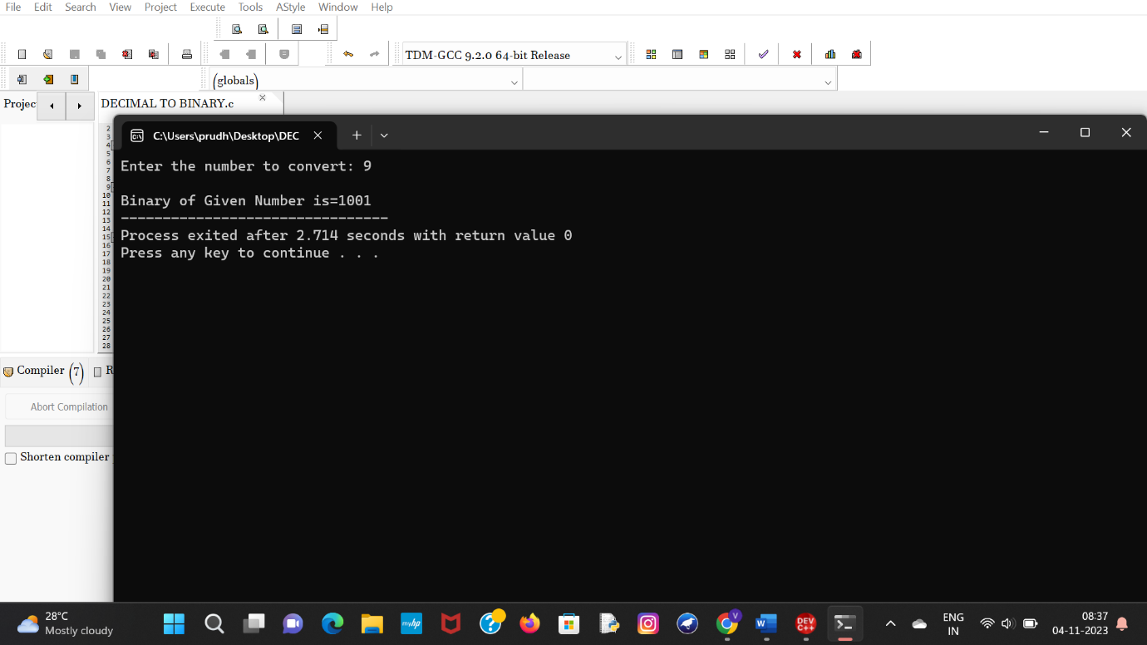  
  
  
  
  
  
**RESULT:**Thus the program was executed successfully using DevC++.